2021 ANSO Board of Directors Elections Nominees

National President

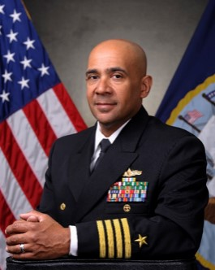

Captain Roy Love, U. S. Navy

I am completely dedicated to ANSO and the ideals and goals of the organization. If selected to be President, I will endeavor to make ANSO a much stronger and better organization than it already is, by dedicating the time and effort required to lead our wonderful team. As President of the DC chapter, together with our team, we have brought quality events and experiences to all ANSO members. My Goal is to expand on our Chapter’s success and make the entire organization the place for all Latino and Hispanic Coast Guard, Navy, and Marine Corps personnel to come and be part of a great family within our respective service communities.

Vote:

- Approve

- Not Approve
Comments:

National Vice President

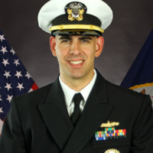

Lieutenant Commander Rolando Jesus Machado Jr., U. S. Navy

I am 100% committed to ANSO and with the support of the BOD, our members and the Sea Service Chiefs, look forward to supporting our nonprofit as National Vice President. Now, more than ever, our Integrated Maritime Force needs motivated leaders to continue the momentum we’ve built despite recent obstacles. COVID-19 has challenged our community as a whole in the workplace, but the resiliency, adaptability, initiative and entrepreneurial spirit embodied by Hispanic Americans across the nation is an asset to our nation’s warfighting capability. Pa’lante seguimos, Full Speed Ahead.

Vote:

- Approve

- Not Approve
Comments:

Membership Coordinator

(Need Photo)

Lieutenant James Aranibar, U. S. Coast Guard (Retired)

(Need Intent)

Vote:

- Approve

- Not Approve
Comments:

Master-At-Arms

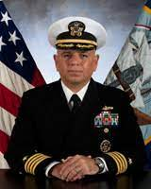

Captain James Earl Kirby, U. S. Navy

As an experienced and successful Hispanic Naval Officer, I am confident that I can effectively execute the ANSO duties of Master-at-Arms for all Association meetings. Additionally, I am committed to achieving the organization's goal, by exemplifying its core values building on our five pillars. I also feel that great emphasis on mentoring our fellow Hispanics and Latinos across all ranks in the United States Sea Services is something that is an absolute essential line of effort.

CWO3 Gil Correa, U. S. Coast Guard

(Need Photo)
(Need Intent)
(I will know by tomorrow)

Vote:

- Approve Captain James Earl Kirby, U. S. Navy

- Approve CWO3 Gil Correa, U. S. Coast Guard
- Not Approve
Comments:

USMC Enlisted Representative

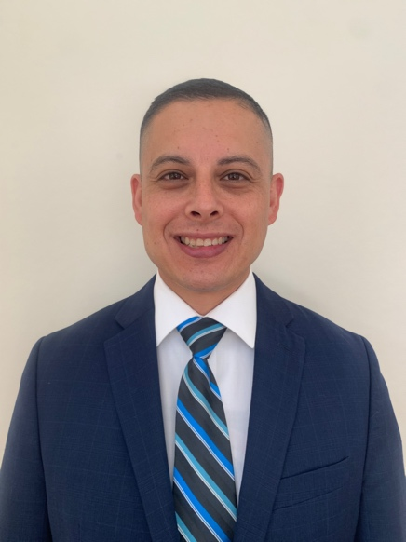

Alfonso Ramos Jr, Veteran, U. S. Marine Corps

I believe I can give back to our Naval Community as the USMC Enlisted Representative for ANSO. I am orgulloso for my hispanic heritage, and noteworthy career in the Marine Corps, which both have shaped the core of my character.

First and foremost, I believe that our people are our most important asset. We all have a story, we all have different keys to success, and we all have different inspirations. It is that diversity that makes us strong!

I learned the value of teamwork and work ethic early on in my life. My story begins in the vast farmlands and orchards of the West Coast where, as a kid, I helped my parents pick crops to make a living. I started my American Dream as a first generation American growing up in a migrant and seasonal farm working family. Then, I learned the value of empathy during my sister Yvette's battle with Leukemia. I remember my family being the subject of two Make-A-Wish foundation trips to Disneyland, and I met some great people at the Valley Children's Hospital in Fresno, CA.
Next, to escape the traumatic event of my sister's passing, moving to Sunnyside, WA in the early 90s was difficult. That is where I learned the value of grit, determination and diligence. Ultimately, I joined the Marine Corps during March 1999. I have attained the highest enlisted rank of Sergeant Major. The Marine Corps is where I learned and embraced my character, leadership, and emotional and interpersonal intelligence.

Through this life journey that I call my story, I hope to inspire others in our ANSO Familia. Andale ANSO!

Vote:

- Approve

- Not Approve
Comments:

